Vertical Ray
# Source: AI Source: Provided by: [Data Path: Persons Table -> ID Column: 1, Name_En Column: Motasem Essam] -> From: [ChatGPT] on [7/25/2026]
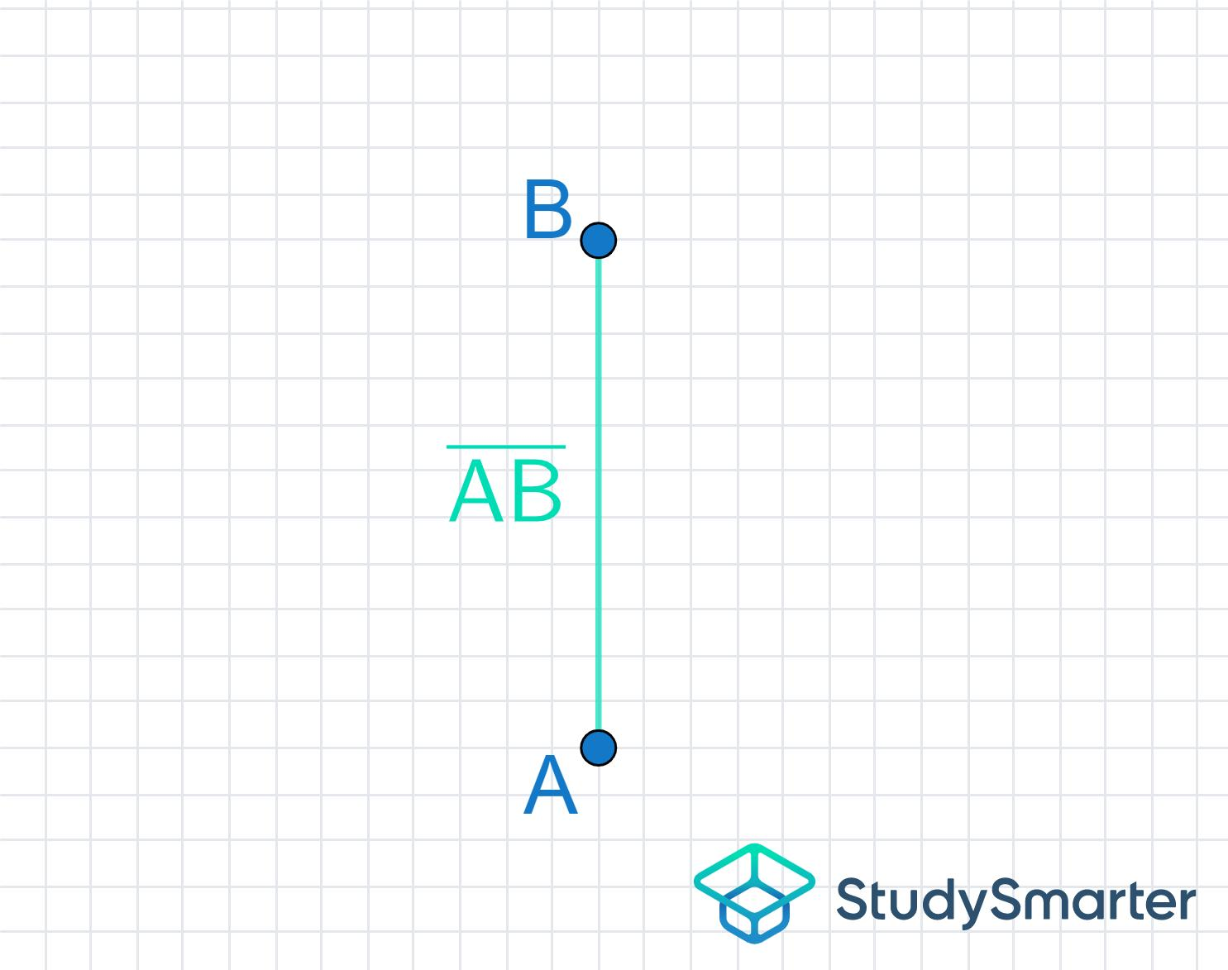
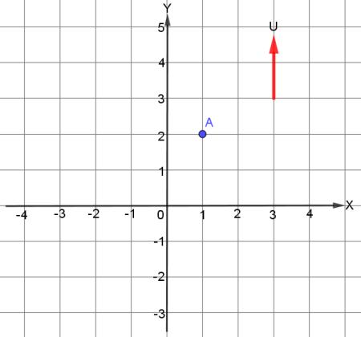
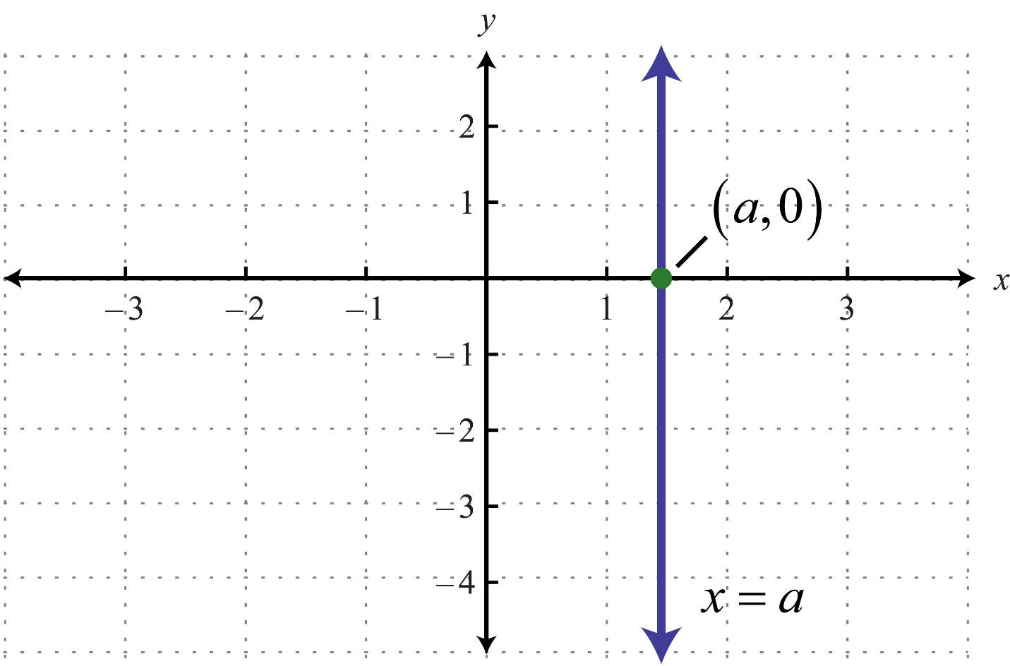

Definition
# Source: AI Source: Provided by: [Data Path: Persons Table -> ID Column: 1, Name_En Column: Motasem Essam] -> From: [ChatGPT] on [7/25/2026]
A Vertical Ray is a ray that extends vertically in one direction from a fixed endpoint. It is parallel to the y-axis and has a constant x-coordinate throughout its length.
Unlike a vertical line or vertical line segment, a vertical ray has one endpoint and extends infinitely in only one direction.

Characteristics
# Source: AI Source: Provided by: [Data Path: Persons Table -> ID Column: 1, Name_En Column: Motasem Essam] -> From: [ChatGPT] on [7/25/2026]
A vertical ray:
- Has one endpoint.
- Extends infinitely in one direction.
- Is parallel to the y-axis.
- Has a constant x-coordinate.
- Has an undefined slope.
- May extend upward or downward.

Illustration
# Source: AI Source: Provided by: [Data Path: Persons Table -> ID Column: 1, Name_En Column: Motasem Essam] -> From: [ChatGPT] on [7/25/2026]
Upward Vertical Ray
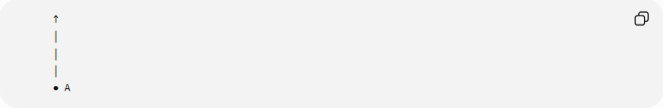
↑
│
│
│
● A

Downward Vertical Ray
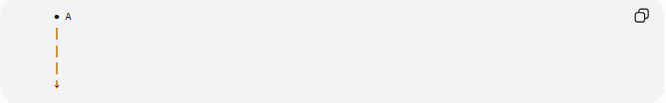
● A
│
│
│
↓

Coordinate Geometry
# Source: AI Source: Provided by: [Data Path: Persons Table -> ID Column: 1, Name_En Column: Motasem Essam] -> From: [ChatGPT] on [7/25/2026]
A vertical ray begins at:
$$A\left(x , y_{0}\right)$$
and extends infinitely while keeping the same x-coordinate.

Upward Ray
Starts at:
$$A\left(4 , 2\right)$$
and extends toward increasing y-values.
All points satisfy:
$$x=4, y≥2$$

Downward Ray
Starts at:
$$A\left(4 , 7\right)$$
and extends toward decreasing y-values.
All points satisfy:
$$x=4, y≤7$$

Slope
The slope of a vertical ray is undefined because
$$m=\frac{Δy}{Δx}$$
and
$$Δx=0$$
Division by zero is undefined.

Examples
# Source: AI Source: Provided by: [Data Path: Persons Table -> ID Column: 1, Name_En Column: Motasem Essam] -> From: [ChatGPT] on [7/25/2026]
Examples of vertical rays include:
- A laser beam projected straight upward.
- A flashlight pointed directly downward.
- A flagpole extending upward from its base (idealized).
- A vertical arrow in a diagram.
- A one-way vertical path.

Properties
# Source: AI Source: Provided by: [Data Path: Persons Table -> ID Column: 1, Name_En Column: Motasem Essam] -> From: [ChatGPT] on [7/25/2026]
A vertical ray:
- Has one endpoint.
- Extends infinitely in one vertical direction.
- Has a constant x-coordinate.
- Has an undefined slope.
- Is parallel to the y-axis.

Applications
# Source: AI Source: Provided by: [Data Path: Persons Table -> ID Column: 1, Name_En Column: Motasem Essam] -> From: [ChatGPT] on [7/25/2026]
Vertical rays are used in:
- Plane Geometry
- Coordinate Geometry
- Engineering
- Architecture
- Construction
- Surveying
- CAD (Computer-Aided Design)
- Technical Drawing
- Computer Graphics
- Robotics

Advantages
# Source: AI Source: Provided by: [Data Path: Persons Table -> ID Column: 1, Name_En Column: Motasem Essam] -> From: [ChatGPT] on [7/25/2026]
Studying vertical rays helps to:
- Understand directed geometric objects.
- Model one-way vertical movement.
- Analyze coordinate systems.
- Construct geometric figures.
- Represent directional paths.

Limitations
# Source: AI Source: Provided by: [Data Path: Persons Table -> ID Column: 1, Name_En Column: Motasem Essam] -> From: [ChatGPT] on [7/25/2026]
A vertical ray:
- Extends in only one direction.
- Represents only vertical orientation.
- Has only one endpoint.

Comparison with Related Objects
# Source: AI Source: Provided by: [Data Path: Persons Table -> ID Column: 1, Name_En Column: Motasem Essam] -> From: [ChatGPT] on [7/25/2026]
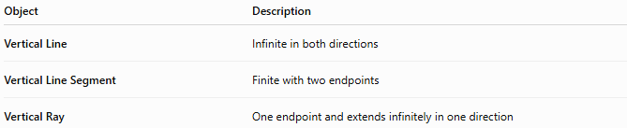
Object | Description
Vertical Line | Infinite in both directions
Vertical Line Segment | Finite with two endpoints
Vertical Ray | One endpoint and extends infinitely in one direction

Key Points
# Source: AI Source: Provided by: [Data Path: Persons Table -> ID Column: 1, Name_En Column: Motasem Essam] -> From: [ChatGPT] on [7/25/2026]
- A Vertical Ray has one endpoint.
- It extends infinitely in one vertical direction.
- All points have the same x-coordinate.
- Its slope is undefined.
- It is parallel to the y-axis.
- Vertical rays are widely used in geometry, engineering, architecture, surveying, CAD, technical drawing, and computer graphics.

Conclusion
# Source: AI Source: Provided by: [Data Path: Persons Table -> ID Column: 1, Name_En Column: Motasem Essam] -> From: [ChatGPT] on [7/25/2026]
A Vertical Ray is a geometric figure that begins at a fixed endpoint and extends infinitely in one vertical direction while maintaining a constant horizontal position. It is parallel to the y-axis and has an undefined slope because there is no horizontal change between its points. Vertical rays are fundamental in plane geometry, coordinate geometry, engineering, architecture, construction, surveying, CAD, technical drawing, robotics, and computer graphics, where they are used to model directed vertical paths, reference directions, and upright geometric relationships.

